**Customer Insights & Seasonal Trends: Analysis & Recommendations**

# **Project Overview**

This project focuses on customer segmentation and purchase behavior analysis to identify top revenue-contributing customers, understand seasonal trends, and evaluate customer retention. By leveraging RFM Analysis (Recency, Frequency, Monetary Value), customers are classified into loyal, new, and inactive segments. Additionally, revenue contribution, purchase frequency, and average order value (AOV) are examined to segment customers effectively. Seasonal spending patterns are analyzed to identify peak months and fluctuations in AOV. Furthermore, product sales during peak months and customer churn rates are assessed to provide actionable insights for enhancing retention and optimizing marketing strategies.

# **Objectives**

1. **Customer Segmentation**: Classify customers based on revenue contribution, purchase frequency, and average order value (AOV).

2. **Behavioral Analysis**: Apply RFM Analysis to categorize customers into loyal, new, and inactive segments.

3. **Seasonality** : Identify seasonal trends and fluctuations in sales and AOV.

**Data Description**

The dataset used for this project is the UK Retail Store Dataset (2010–2011), containing transactional data from an online retail store. The dataset comprises the following columns:

- **InvoiceNo**: Unique identifier for each transaction.

- **StockCode**: Unique product code for each item.

- **Description**: Product description.

- **Quantity**: Number of units sold per transaction.

- **InvoiceDate**: Date and time of each transaction.

- **UnitPrice**: Price per unit of the product.

- **CustomerID**: Unique identifier for each customer.

- **Country**: Country of the customer making the purchase.

**Executive Summary** -

This report analyzes customer segmentation and seasonal trends from the UK Retail Store Dataset (2010–2011). Findings highlight revenue concentration among top customers, high churn risk from at-risk segments, and revenue peaks in November and December. Recommendations include loyalty programs, re-engagement of at-risk customers, enhanced marketing during peak months, and optimized discount strategies.

**Customer Behaviour and Segmentation Report** -

# **Customer Segmentation Analysis:** This analysis intends to identify potential revenue generating customer which might drive sales and revenue

## **Top 10% Revenue-Contributing Customers**

- Contribute approximately 52% of total revenue.  
 - Highest revenue contributor: Customer 14911 (£126,774.57).  
 - Top five customers (IDs: 14911, 14646, 14096, 14156, 13089) generate £366,996.75 (11% of total revenue).

**Key Insight**: Revenue is heavily concentrated among a small group of customers, making them critical for sustained profitability.

## **High-Value Segment Analysis**

- Total Revenue (Top 10% Customers): £3,321,754.32.  
 - Average Purchase Frequency: 20 orders per customer.  
 - Average Order Value (AOV): £490.87.

**Insight**: High purchase frequency and AOV indicate strong customer loyalty and purchasing power.

**Recommendations**: Implement loyalty programs, personalized offers, upselling, and cross-selling strategies.

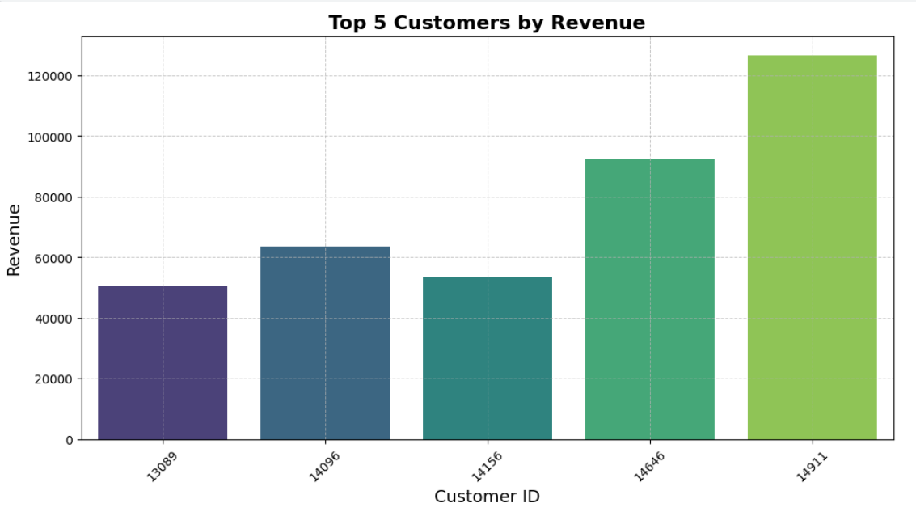

# **B. Customer Segmentation**

# **Overview**

The analysis identifies five distinct customer segments:  
 - **Regular Customers** (39.32%) - Consistent buyers; moderate frequency and spending.  
 - **New Customers** (28.45%) - Recently acquired; retention potential.  
 - **At-Risk Customers** (21.91%) - Previously valuable customers showing inactivity; high churn risk.  
 - **Lost Customers** (7.25%) - Likely churned; mostly one-time buyers.  
 - **Loyal Customers** (3.06%) - High-frequency, high-value customers; critical for long-term profitability.

**Key Insights:**  
 - High churn risk (29.16%) from **At-Risk** and **Lost** segments.  
 - **Loyal customers** are valuable but **underrepresented.**  
 - **At-Risk** customers offer a promising revenue recovery opportunity if effectively **re-engaged**.

**Recommendations**: Improve retention, re-engage At-Risk customers, enhance new customer conversion, and address pain points to reduce churn.

# **C. Seasonality Analysis**

The seasonality analysis aims to identify trends and patterns in sales and customer spending over time. By examining revenue trends, monthly sales distribution, and average order values (AOV), valuable insights are drawn to support strategic decision-making and improve overall business performance.

## **Key insights**

1. **Monthly Sales Distribution**:  
    - Sales are highest in November (15% of total revenue) due to seasonal promotions and holiday demand.  
    - December follows closely, contributing around 11% of revenue.  
    - Low sales periods include May and June (~5% each), suggesting potential seasonal downturns.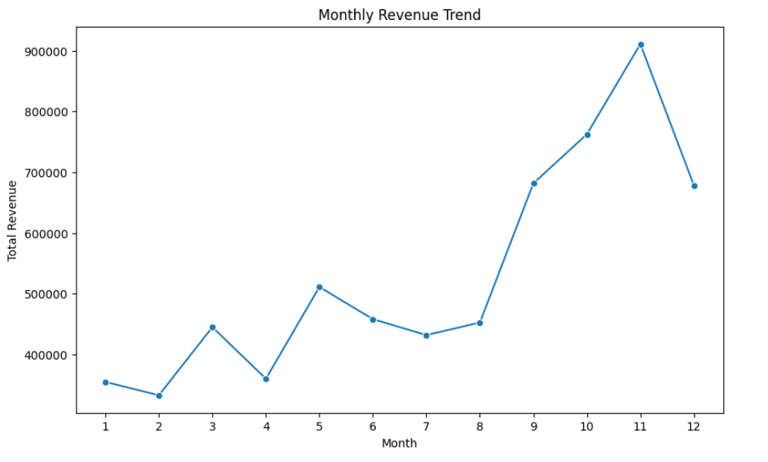
2. **Revenue Trends**:  
    - Cyclical pattern with peaks during November and December (26% of annual revenue).  
    - Significant revenue dip during mid-year (May-June).
3. **Average Order Value (AOV):**  
    - High AOV in November and December due to bulk orders and high-value purchases.  
    - Low AOV during May and June, aligning with the observed revenue dip.
4. 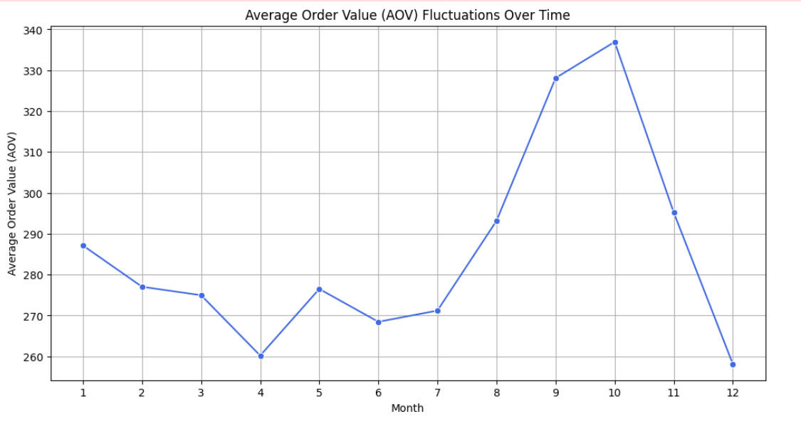

**Recommendations**

1. Leverage High-Demand Months (November & December):

* Increase marketing efforts and targeted promotions to boost repeat purchases.

2. Mitigate Low Sales Periods (May & June):

- Offer special discounts, bundles, and supplier collaborations to attract customers.  
 - Evaluate discount strategies for high-value and low-value customers to enhance profitability.  
 - Implement loyalty programs and predictive modeling for efficient resource allocation.

## 

## 

## **Conclusion**

## High revenue concentration among a small group of top customers, highlighting the importance of retention strategies.

* Strong seasonality trends suggest November and December are critical months for revenue generation.
* At-Risk and Lost segments represent significant churn risk but also potential revenue recovery opportunities if effectively targeted.

## **Recommended Actions :**

* *Customer Retention*: Implement loyalty programs, personalized offers, and targeted marketing for high-value customers.
* *Revenue Recovery*: Re-engage At-Risk and Lost customers with promotions, tailored communications, and exclusive offers.
* *Seasonal Marketing*: Enhance marketing efforts during peak months and introduce discounts or bundles during low-demand periods.
* *Segment-Specific Strategies*: Develop tailored strategies for different customer segments to maximize revenue potential and retention.